

**Prepared by :**

**Oliver Thomas**

**Frerejean Thibault**

**Caron Fabien**

**Rivoherinjakanavalona Nathalie**

Software Requirements Specification

for

OK+ Project

Version 1.0 approved

**SEYED ALI JANNATPOUR**

**UML - CEWP MOD5B GRB 2174**

Table of Contents

[1 Introduction 3](#_Toc514863415)

[1.1 Purpose 3](#_Toc514863416)

[1.2 Intended Audience and Reading Suggestions 3](#_Toc514863417)

[2 Overall Description 3](#_Toc514863418)

[2.1 Product features 3](#_Toc514863419)

[2.2 User Classes and Characteristics 3](#_Toc514863420)

[3 SYSTEM FEATURES 4](#_Toc514863421)

[3.1 Use-Case Diagram 4](#_Toc514863422)

[3.1 Class Diagram 4](#_Toc514863423)

[3.2 Create account Use-case 6](#_Toc514863424)

[3.2.1 Scenario 6](#_Toc514863425)

[3.2.2 Sequence Diagram 6](#_Toc514863426)

[3.3 Log in Use-case 7](#_Toc514863427)

[3.3.1 Scenario 7](#_Toc514863428)

[3.3.2 Sequence Diagram 7](#_Toc514863429)

[3.4 Buy product Use-case 8](#_Toc514863430)

[3.4.1 Scenario 8](#_Toc514863431)

[3.4.2 Sequence Diagram 8](#_Toc514863432)

[3.5 Sell product Use-case 9](#_Toc514863433)

[3.5.1 Scenario 9](#_Toc514863434)

[3.5.2 Sequence Diagram 9](#_Toc514863435)

[4 External Interface Requirements 10](#_Toc514863436)

[4.1 4.1 User Interfaces 10](#_Toc514863437)

[4.1.1 Principal Window 10](#_Toc514863438)

[4.1.2 Sign Up Window 10](#_Toc514863439)

[4.1.3 Client Window 11](#_Toc514863440)

[4.1.4 Sell Product Window 11](#_Toc514863441)

[4.2 Software Interfaces 12](#_Toc514863442)

[4.2.1 Database 12](#_Toc514863443)

[4.3 Communications Interfaces 12](#_Toc514863444)

[4.3.1 Containers 12](#_Toc514863445)

[4.3.2 Session 12](#_Toc514863446)

[4.3.3 Strategy-Ddesign pattern 12](#_Toc514863447)

[5 Appendix A : Issues list 13](#_Toc514863448)

[6 Appendix B : Table of figures 14](#_Toc514863449)

# Introduction

## Purpose

Unified Modeling Language is a generic modeling language used in software engineering field, in order to provide a standard way to present the design of a system. The goal of doing a project for the UML course is precisely to develop a system, in a team, and to use the tools in UML to carry out the project.

We are a team of 4 people, and we decided to develop an application for an e-commerce company. It is a sale and purchase platform between individuals.

In this report, we will see first, the project analysis phase, then the front-end and back-end development of the system.

## Intended Audience and Reading Suggestions

This document is intended for all people who want to know the operation, and the tools which are used for the Ok+ application. This is for developer, in order to help them to achieve, improve or update the project. This is for project manager to oversee the project, and to see the progress of the project.

# Overall Description

## Product features

The application Ok+ is a platform for individual where they are able to sale product or/and buy product. The user can sign up by providing personal information. Once registered, he can log in an start buy product. He has an area for selling product. He has wallet and cart. The user can log out anytime he wants.

## User Classes and Characteristics

We can identify one user classes in our system, but the user is a seller and a buyer.

Customer : A customer is the principal user of the application. He has 2 roles which are seller and buyer. He has a wallet with an amount of money. He has a wallet in the application, and he can add money from his bank account, or by selling a product, he can earn money. He can also put money in his bank account from the wallet of the application.

Seller : The seller can add new product for sell. The user has to complete form about the product, which requires the name of the product, the price, a comment about the product, and the type of the product. Once the form completed, other users can see the new product in the shop.

Buyer : The buyer has access to the shop and can display products switch type of the product. The user can select a product to add it in his cart. He can remove some items from his cart, or remove all items. Once he has selected all items he needs, he can buy his cart’s content.

# SYSTEM FEATURES

## Use-Case Diagram

The following diagram is our Use-case Diagram. That summarizes actors of the system and what they are able to do or not to do. In our system, we have one actor, which is the customer. The customer is a seller and a buyer at the same time. So we have 3 different roles in the system.

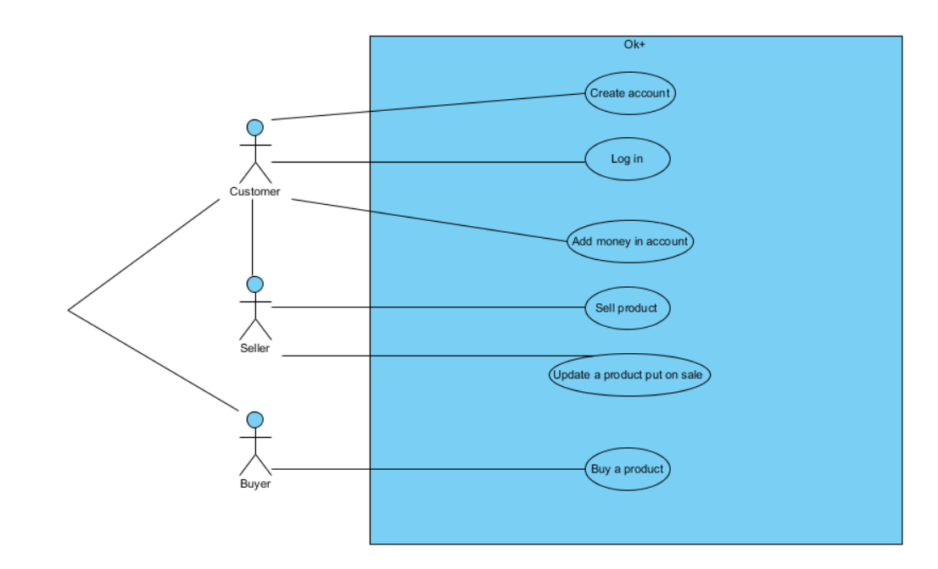

Figure 1 - Use-case Diagram

## Class Diagram

The Class Diagram allows us to see how classes are related to each other. For each class, it allows to know it private attributes, private and public methods.

Figure 4 - Class Diagram



Figure 2 - Use-case Diagram

## Create account Use-case

The following diagrams, are the scenario and sequence diagram of the “Create account” use-case.

### Scenario

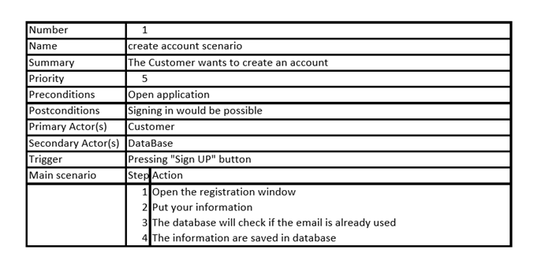

Figure 3 - Scenario - Create account use-case

### Sequence Diagram

Une image contenant capture d’écran

Description générée avec un niveau de confiance élevé

Figure 4 - Sequence Diagram – Create account

## Log in Use-case

The following diagrams, are the scenario and sequence diagram of the “Log in” use-case.

### Scenario

|  |  |  |
| --- | --- | --- |
| Number | 2 | |
| Name | Log in scenario | |
| Summary | The customer wants to log in the system | |
| Priority | 4 | |
| Preconditions | Open application and already registered | |
| PostConditions | Access to the client session | |
| PrimaryActor(s) | Customer | |
| SecondaryActor(s) | DataBase | |
| Trigger | Pressing "Sign In" button | |
| Main Scenario | Step | Action |
|  | 1 | Put email address and password |
|  | 2 | Database check if the email address already exists and if it matches with a password |
|  | 3 | Customer can access to his session |

Figure 4 - Scenario - Log in use-case

### ../../Downloads/33207265_872962359558795_5220148335830106112_n.pngSequence Diagram

Figure 5 - Sequence diagram - Log in use-case

## Buy product Use-case

The following diagrams, are the scenario and sequence diagram of the “buy product” use-case.

### Scenario

|  |  |  |
| --- | --- | --- |
| Number | 6 | |
| Name | Buy product scenario | |
| Summary | The buyer wants to buy a product | |
| Priority | 4 | |
| Preconditions | Buyer has at least one item in his cart and has enough money | |
| Post Conditions | Buyer ‘balance changes | |
| Primary Actor(s) | Customer | |
| Secondary Actor(s) | DataBase | |
| Trigger | Pressing "Buy" button | |
| Main Scenario | Step | Action |
|  | 1 | Get the product ‘price |
|  | 2 | Update balance of the buyer |

Figure 6 - Scenario - Buy product use-case

### Sequence Diagram

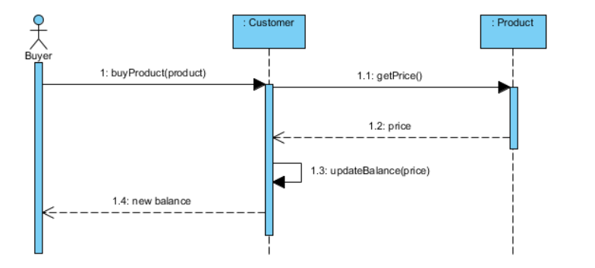

Figure 7 - Sequence Diagram - Buy product use-case

## Sell product Use-case

The following diagrams, are the scenario and sequence diagram of the “Sell product” use-case.

### Scenario

|  |  |  |
| --- | --- | --- |
| Number | 4 | |
| Name | Sell product scenario | |
| Summary | The customer wants to sell a product | |
| Priority | 4 | |
| Preconditions | Seller is in his session | |
| PostConditions | Add a product in Catalog | |
| PrimaryActor(s) | Customer | |
| SecondaryActor(s) | DataBase | |
| Trigger | Pressing "Sell product" button | |
| Main Scenario | Step | Action |
|  | 1 | Put Information of the product |
|  | 2 | Database add the product |

Figure 8 - Scenario - Sell product use-case

### https://scontent-yyz1-1.xx.fbcdn.net/v/t1.15752-9/33357378_872967829558248_4913534035067666432_n.png?_nc_cat=0&oh=e96196379c4c388231bb30ec08ac11d6&oe=5B8F44C2Sequence Diagram

Figure 9 - Sequence Diagram - Sell product use-case

# External Interface Requirements

## 4.1 User Interfaces

Swing library of Java is used to design the user interface.

### Principal Window

Figure 10 - Princiapl window

Product list

### Sign Up Window

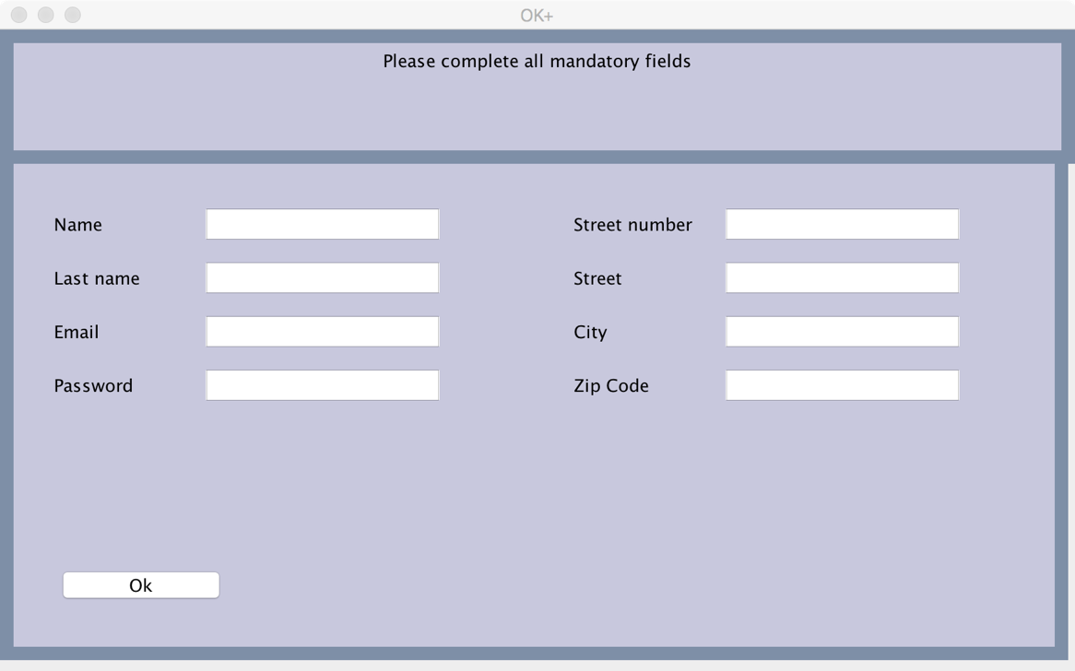 This window shows up when the user click on “Sign up” button from principal window.

Figure 11 - Sign Up window

### Client Window

This window shows up when a user log in the application. It is the user’s session.

Client’s balance

Client’s cart

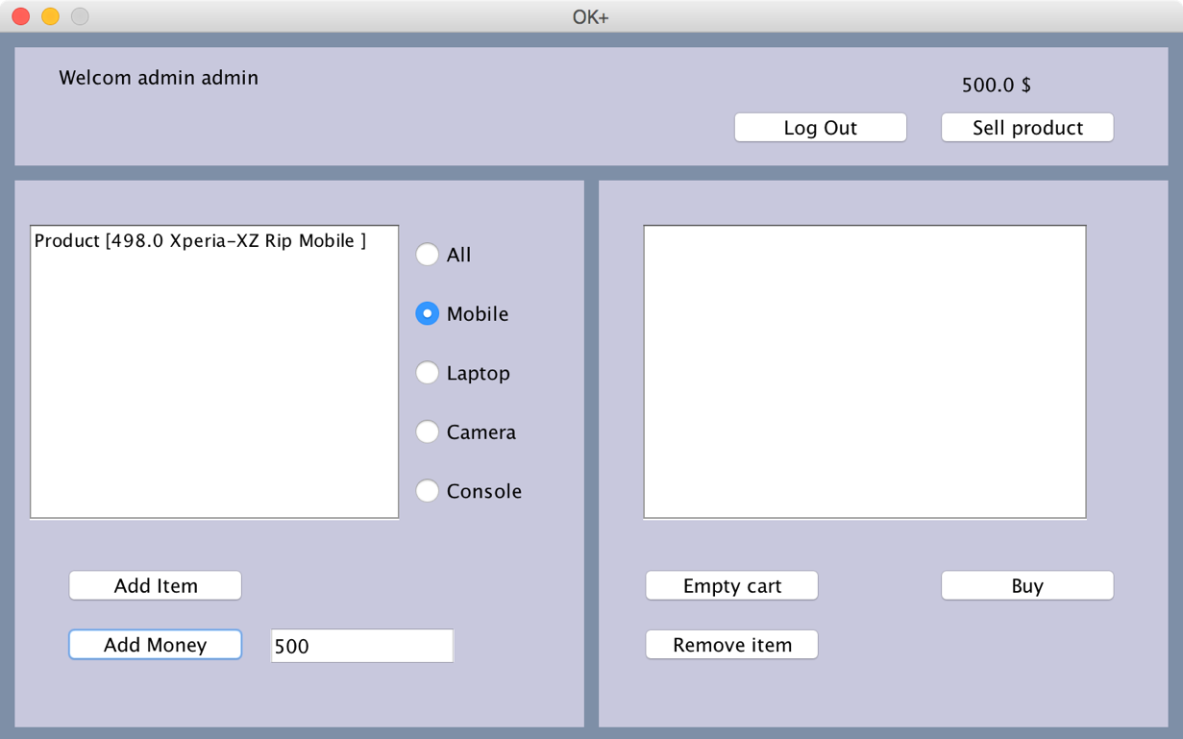

### Sell Product Window

This window shows up when the user wants to add an item for sale.

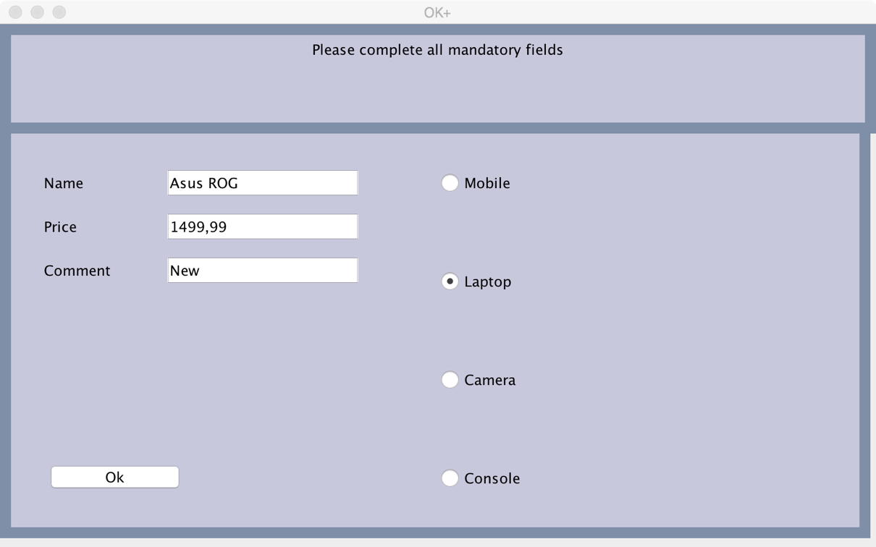

## Software Interfaces

### Database

Database of the project is handle by file in the application. When the application is runned, it imports all data for users and products from different file. When the application is closed, it exports all users and products. The addition, modification, deletion or any operation done on a data is not done in real time in the files.

2 files are required for the application :

* Product.txt : products list
* Customer.txt : customers list

## Communications Interfaces

### Containers

Customer and product container are SINGLETON. Each time a product is added or a new user is created, it is added in the corresponding container. There is only one user container and one product container. All windows share the same user and product container.

### Session

Each window which is related to user session has in parameter the user of the current session. We retrieve the user in the principal window when the user is logging in.

### Strategy-Ddesign pattern

In our application we choose to implement some kind of database in order to able some persistence for the data. We first implemented a file database, but in the future it was suppose to evolve and used a real Database, like Mysql or Sqlite. We decided to use the Design pattern strategy to implement the directory, so if we want to switch from file directory to database, it will be easier and more manageable.

# 

# Appendix A : Issues list

|  |  |  |  |
| --- | --- | --- | --- |
| Interfaces | # | Descriptions | Solutions |
| 1 | No image for product | Re-design the diplay of product list |
| 2 | We can't exit Sign up window without sign up | Add "Cancel" button |
| 3 | We can't exit Sell product window without sign up |
| Data | 1 | Critical section problem | Use thread to synchronize data |
| 2 | We can't update data in real time | Use database |
| 3 | Storage issue |

# Appendix B : Table of figures

Figure 1 - Use-case Diagram 4

Figure 4 - Class Diagram 4

Figure 3 - Scenario - Create account use-case 6

Figure 4 - Scenario - Log in use-case 7

Figure 5 - Sequence diagram - Log in use-case 7

Figure 6 - Scenario - Buy product use-case 8

Figure 7 - Sequence Diagram - Buy product use-case 8

Figure 8 - Scenario - Sell product use-case 9

Figure 9 - Sequence Diagram - Sell product use-case 9

Figure 10 - Princiapl window 10

Figure 11 - Sign Up window 10